**Hystrix Integration**

**Two Service are created:**

1. **service-circuitbreaker** (In this application Hystrix is integrated and in this internally we are calling the producer service to get the message )
2. **service-producer** (This service will produce the message)

**URL** : <https://service-circuitbreaker.labash.inbcu.com/hello>

Here message is received from the producer service

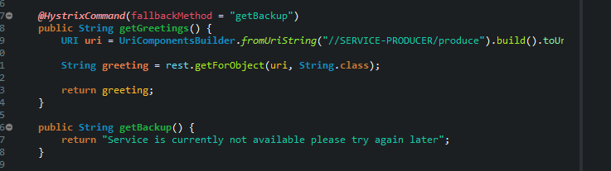

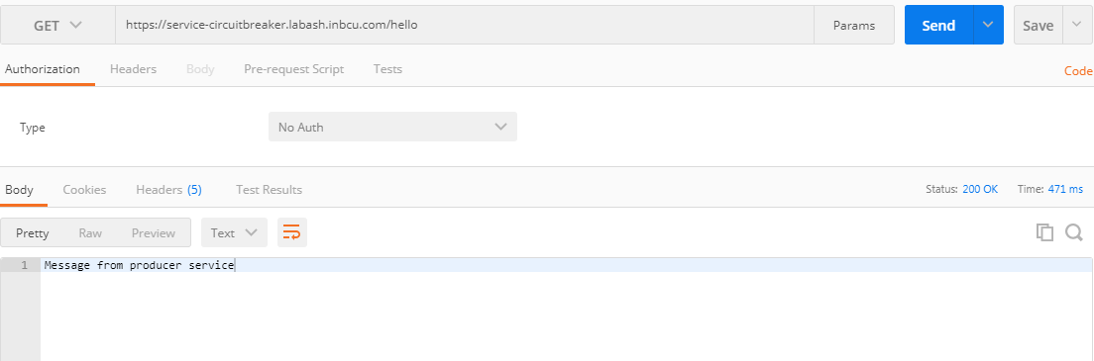

**Hystix Dashboard:**

Here there is no failure the service producer call will happen without any problem

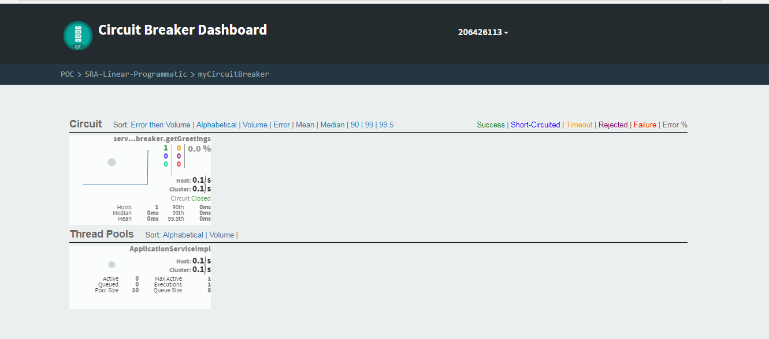

**Producer service is stopped:**

In order to test Hystrix functionally the application is stopped.

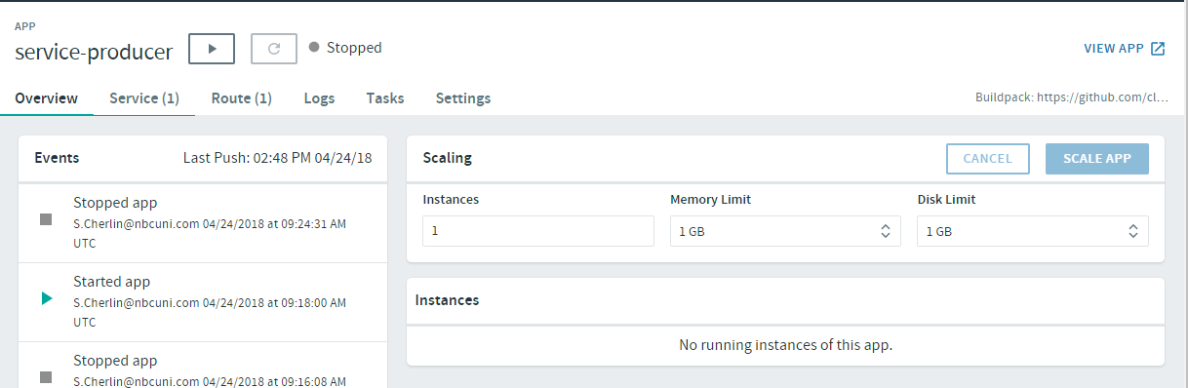

**URL** : <https://service-circuitbreaker.labash.inbcu.com/hello>

Fallback message is received

